H.T No
Regulations:
A18

Sreenidhi Institute of Science and Technology
(An Autonomous Institution)
Code No: 7K301 Date: 08-Mar-2021 (FN)

B.Tech II-Year I- Semester External Examination, March/April-2021 (Regular & Supplementary)
INTRODUCTION TO SOLID MECHANICS-I (CIVIL)

Time: 3 Hours Max.Marks:70

Note: a) No additional answer sheets will be provided.
b) All sub-parts of a question must be answered at one place only, otherwise it will not be valued.
c) Missing data can be assumed suitably.

ANSWER ANY 5 OUT OF 8 QUESTIONS. EACH QUESTION CARRIES 14 MARKS.

Bloom's Cognitive Levels of Learning (BCLL)

Remember | L1 | Apply | L3 | Evaluate | L5
Understand | L2 | Analyze | L4 | Create | L6

 |  |  | BCLL | CO(s) | Marks
1. | a) | A rod of steel 6cm wide, 1.5cm thick and 800cm long extends by 0.558cm when an axial pull of 1200 kg. Find the modulus of elasticity of steel. | L3 | CO1 | [7M]
 | b) | A steel bar of varying sections is subjected to the axial forces as shown in figure. Find the values of P necessary for equilibrium. If E = 210 kN/mm², determine the total elongation of the bar.  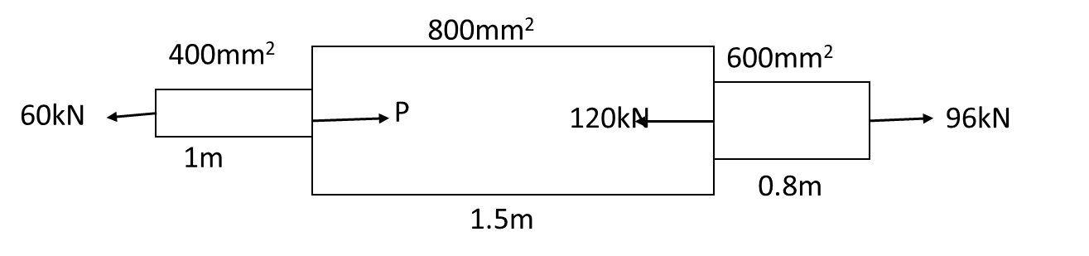 | L3 | CO1 | [7M]
2. | a) | A beam, 6m long is simply supported at the ends and carries a uniformly distributed load of 15 kN/m and three concentrated loads of 10kN, 20kN and 30kN acting respectively at the left quarter point, centre point and right quarter point. Draw the S.F and B.M diagrams and determine the maximum bending moment. | L3 | CO2 | [7M]
 | b) | A beam 5m long, supported at the ends carries point loads of 14 tonnes, 6 tonnes and 8 tonnes at distances 0.5m, 2.5m and 3.5m respectively from the left end. Find the maximum S.F and B.M. Draw the S.F and B.M diagrams. | L3 | CO2 | [7M]
3. |  | Derive the relation.  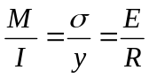 | L3 | CO3 | [14M]
4. |  | A cantilever, 2.4m long is loaded as shown in figure. Calculate the deflection at the free end if the section is rectangular, 120 mm x 240 mm. take E = 0.11 x 10⁵ N/mm²  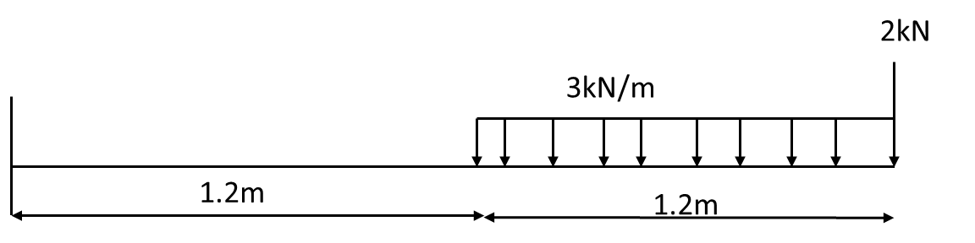 | L3 | CO4 | [14M]
5. | a) | the principal stresses at a certain point in a strained material are 1200 kg/cm² And 480 kg/cm² both tensile. Find the normal and tangential stresses on a plate inclines at 20 degrees with the major principle plane. | L3 | CO5 | [7M]
 | b) | In a plane stress system, the normal stresses on X- and y- lanes are 200 MPa and -100MPa, respectively and the shear stress on the X-planes is 80 MPa. Determine the directions of the principal planes and the principal stresses. | L3 | CO5 | [7M]
6. | a) | Explain maximum shear stress theory of failure with neat sketches. | L2 | CO6 | [7M]
 | b) | A Rectangular beam 100mm wide and 250mm deep is subjected maximum shear force 50kN. Determine Average shear stress, Maximum shear stress and shear stress at a distance 25mm from neutral axis. | L2 | CO6 | [7M]
7. | a) | Draw the S.F and B.M diagrams for a cantilever of length L carrying a point load at the free end. | L2 | CO2 | [7M]
 | b) | What are the assumptions in the theory of simple bending? | L2 | CO3 | [7M]
8. | a) | Derive an expression for the slope and deflection of a beam subjected to uniform bending moment. | L3 | CO4 | [7M]
 | b) | Show that for a rectangular section of the maximum stress is 1.5 times the average stress. | L2 | CO6 | [7M]

-- 00 -- 00 –

